**Communication Labs**

**Spring 2023**

**Assignment 1**

**Tiger Grandma**

Prepared by:

Genie Hou (ch3801)

Ajla Šačić (as15471)

Eric Asare (ea2525)

Swostik Pati (sp6441)

Instructor:

Dr Evi Mansor

Table of contents

1. INTRODUCTION 4

2. MEET THE TEAM 4

3. PHASE ONE: PLANNING 5

***3.1*** ***Brainstorming Story Ideas*** 5

**3.2** **The Story Atmosphere and Scenes** 6

4. PHASE TWO: DESIGN 7

**4.1** **Story Outline and Dialogue** 7

**4.2** **Recording the Characters** 9

**4.3** **Generating Visual Representation** 10

**4.4** **Website Design** 12

5. PHASE THREE: IMPLEMENTATION 15

**5.1** **Sound Editing** 15

**5.2** **Website Development** 16

6. PHASE FOUR: DELIVERY 19

7. REFLECTION 20

8. REFERENCES 22

9. APPENDIX 24

list of figures

Figure 1 First Team Meeting Storyboard 4

Figure 2 Grandaunt Tiger by HodariNundu on Deviantart 7

Figure 3 Behind the scenes of sound recording 8

Figure 4 Family together at the dinner table 9

Figure 5 Tiger Grandma appears in the bedroom at night 9

Figure 6 Daughter wakes up from dream in the morning 10

Figure 7 Opening page wireframe 10

Figure 8 Sound playing page wireframe 11

Figure 9 Ending page wireframe 11

Figure 10 Behind the scenes page wireframe 12

Figure 11 Website title page 12

Figure 12 Play button 13

Figure 13 Next Scene Button 13

Figure 14 Replay button 13

Figure 15 Opening page 15

Figure 16 Scene 1 (after audio ends) 16

Figure 17 Scene 2 (before audio ends) 16

Figure 18 Replay page 17

Figure 19 Behind the scenes page 17

List of tables

Table 1 Three Week Overview Plan 19

# **INTRODUCTION**

The project was focused on producing sound in order to create an immersive story or experience. The aim of this project was to utilise sound recording and editing devices and software to create high-quality sound that was used to deliver a traditional Taiwanese folklore story. The project's main focus, apart from sound design, is to preserve one country’s oral folklore. Although not all team members are from Taiwan, by delivering the story, the team was able to understand the importance of cultural heritage and history, as well as the wisdom behind the story, which was respect towards the elderly, especially one’s own parents. The sound enabled the team to appreciate the intricacies of both sound production and the art of storytelling itself. This report provides a comprehensive overview of the project, a detailed analysis of the planning, execution and delivery phases. Furthermore, the team reflects on the impact and value of sound production, its challenges to demonstrate its importance in the industry, storytelling the the world as we know it today.

# **MEET THE TEAM**

|  |  |
| --- | --- |
|  |  |
| **Ajla**  Leader, Sound Production and Editing, Storyboard | **Genie**  Sound production and Editing, Storyboard, Image editing |
|  |  |
| **Swostik**  Lead Web Development, Sound Production | **Eric**  Web Development, Sound Production, Image production |

# **PHASE ONE: PLANNING**

## ***Brainstorming Story Ideas***

The first team meeting was used for brainstorming ideas for the project. Since none of the team members are music majors, or musically inclined, the first step was very challenging. To come up with an original idea is something that most people struggle with, no matter their specialization, so the process was not as straightforward as possible. However, four heads are better than one when it comes to the ideation process. By discussing their different backgrounds, the team was able to come up with the idea to portray a traditional Taiwanese folklore story that goes by the name of “The Tiger Grandma”. The initial step was to shorten the story such that it fits within the two-to-three-minute time allowed by the project. By excluding long backstories and focusing on an original story that encompasses the idea of the tiger grandma, the team was able to produce a nice homage to Taiwanese oral history as well as ideate on the audio aspects of the project. A whiteboard was used to finish up the initial brainstorming session and take first steps towards starting the main part of the project, sound production. Pictured below is the conceptualization of the story on the whiteboard during the initial meeting.

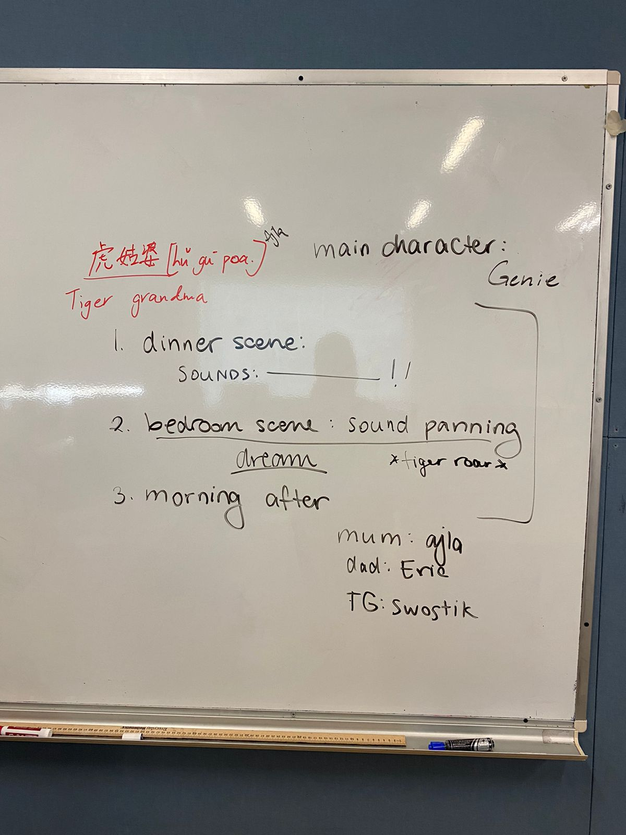

Figure 1 First Team Meeting Storyboard

## **The Story Atmosphere and Scenes**

The initial brainstorming session allowed the team to think of the atmosphere and scenes. Since the project is intended to develop a sense for sound production, the team thought of having three themes that would portray different emotions, namely, anger, fear, and relief. The atmosphere of the scenes was to be emulated through different ambient sound and music which would also encompass traditional Taiwanese music. By introducing sounds such as tiger roar, as seen in the brainstorming whiteboard, the team would be able to portray the existence of the mythical creatures without having to portray it in full detail visually. However, visual aspects were important as well. Hence, the team immediately decided on utilising Artificial Intelligence (AI) to give the scenes more character and provide those with hearing difficulties with some background to the story. The use of AI is discussed later in the report. To end the planning phase, the team divided the voiceover roles to each of the team members. By designating for roles within the story, namely the mother, father, daughter and the tiger grandma, all team members were able to fill a role such as to fully engage with the story and sound production

# **PHASE TWO: DESIGN**

## **Story Outline and Dialogue**

# Although the story was already set up, the team was keen on adding more details to the story and also encompassing the original one behind the Tiger Grandma. The original story was initially written down in its original form such as to try and incorporate as many details as possible that would preserve the meaning behind it. Afterwards the team began to write their own story and dialogue that would help them start recording the dialogue and searching for the background sound of the story. The dialogue was divided according to the scenes during the second team meeting and written between the first and second week of the project development. Below is the full transcript of the dialogue which also includes the background noises, sound effects and ambience sound.

|  |
| --- |
| **Scene 1 (Dinner):**  **Narration: *explain the scene\***  It was a stormy night in Taipei. The matriarch of the [surname] family had just set up the dinner table and called her husband and daughter to join. Mr [surname] joined his wife at the table and waited for their daughter to come.  **Dialogue**  ***\*footsteps on parquet floor, background music, ambient noise\****  ***\*chair pulling out\****  **Daughter:** Ugh, bitter melon again?! I don't understand why we have to eat this nasty vegetable. It's so bitter and gross. I wish we could have something else for dinner. This is just not fair.  **Mother:** Sit down and eat your food.  **Daughter:** No, I want chicken nuggets! You always make your favorite food, when is it my turn? I WANT CHICKEN NUGGETS FOR ONCE!  **Mother: I**f you don’t stop right now and behave, the Tiger Grandma is going to come eat you alive.  **Daughter:** *Mum*, I am not five years old anymore. Such fairytales don’t scare me anymore. I won’t eat!  **Dad:** You will sit at the table until you eat your food!  **Daughter:** But *DAAAAD*! You know I hate bitter melon!  **Dad:** Don’t argue with us. It’s disrespectful.  **Daughter:** Of course it is! You always do this when we disagree. I’m tired of it…  **Dad:** That is enough! (smack at the table sound)  **Mum**: You won’t have dinner! Go to your room right now.  **Daughter**: FINE! I HATE YOU GUYS!  ***\* chair pulling out aggressively, stomping, door slam\****  [Daughter stomps off to her room]  **Sound: cutlery, eating, dialogue, traditional Taiwanese music**  **Scene 2 (Bedroom):**  [Daughter locks her room door and goes to her bed]  Daughter (mumbling): Stupid bitter melon. Why can’t we eat normal food.  [falls asleep]  ***\*increasing intense ambience sound\****  *\*****wind blowing the window, lightning\****  [Daughter wakes up]  **Daughter**: Why is it so cold in here? Wait… Why is the window open!  [Daughter walks to the window]  ***\*footsteps, window closing\****  [Daughter turns around towards the bed and sees a pair of beaming eyes in the corner]  **Daughter**: AHHH!  ***\*heavy breathing\****  [Tiger Grandma comes out of the shadow]  ***\*heavy footsteps\****  **Tiger Grandma**: I heard there is a little girl here who does not behave. She even yells at her parents.  [Tiger grandma approaches]  ***\*heavy breathing\****  **Daughter**: No! I’ll never do it again! Please don’t hurt me.  [Daughter starts crying out of fear]  **Tiger Grandma**: No, it is too late and it is my time to have dinner because I am very very very HUNGRY(hungry echo).  [Tiger grandma roars, Daughter screams]  **Sound: walking around the room, dialogue of sounds panning from left to right, little girl crying**  **Scene 3 (Morning after, Bedroom):**  The daughter woke up from the roar screaming from her dream. And she starts breathing heavily trying to calm down from the terror.  **Sound: heavy breathing, birds chirping to show it is the morning** |

To finish off the design process, the team looked at different interpretations of the tiger grandma, such as the one pictured in the picture below (Figure 2). The photos gave a general idea of the appearance of the visual aid that would be produced with the AI later on in the development process.

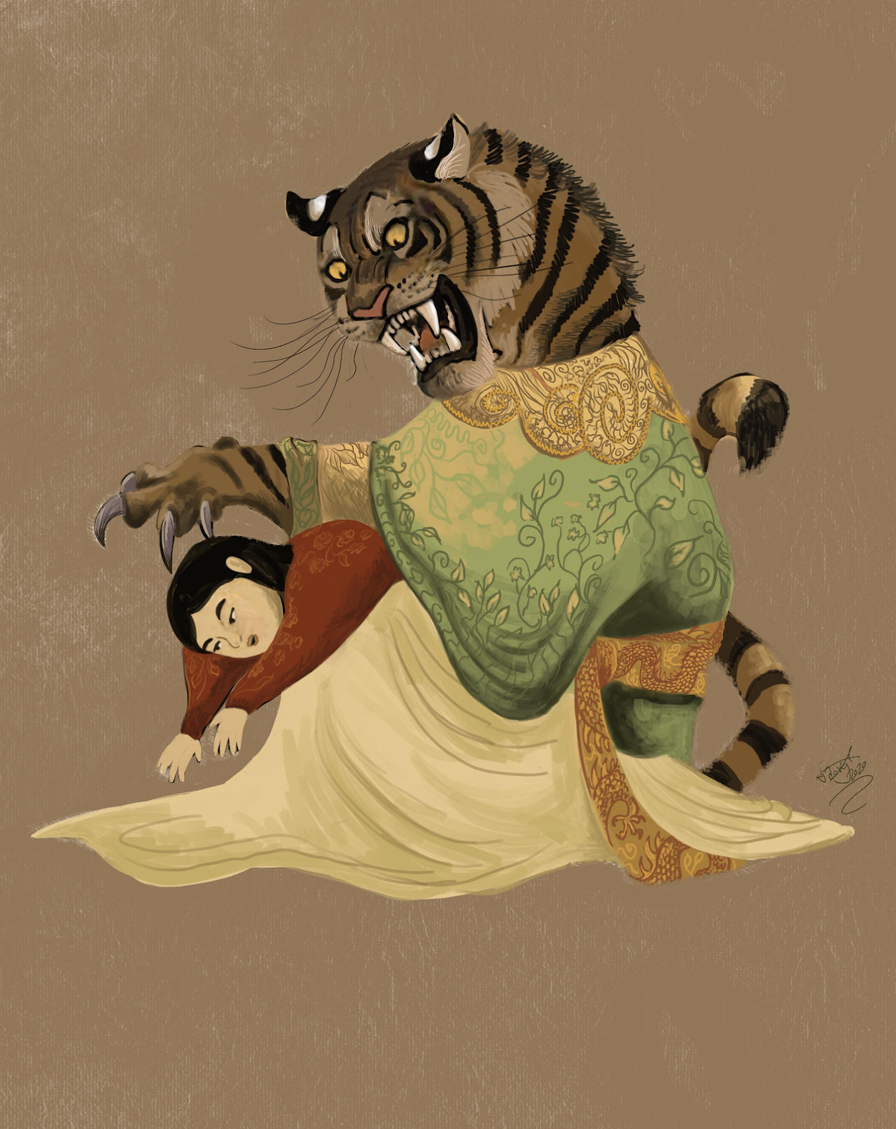

Figure 2 Grandaunt Tiger by HodariNundu on Deviantart

## **Recording the Characters**

# The three scenes were recorded during a meeting in a composition room. The room was specifically chosen for its soundproof walls and lack of noise such as wind and conversation. Pictured below is one of the behind-the-scenes photos taken during the recording of the dialogue.

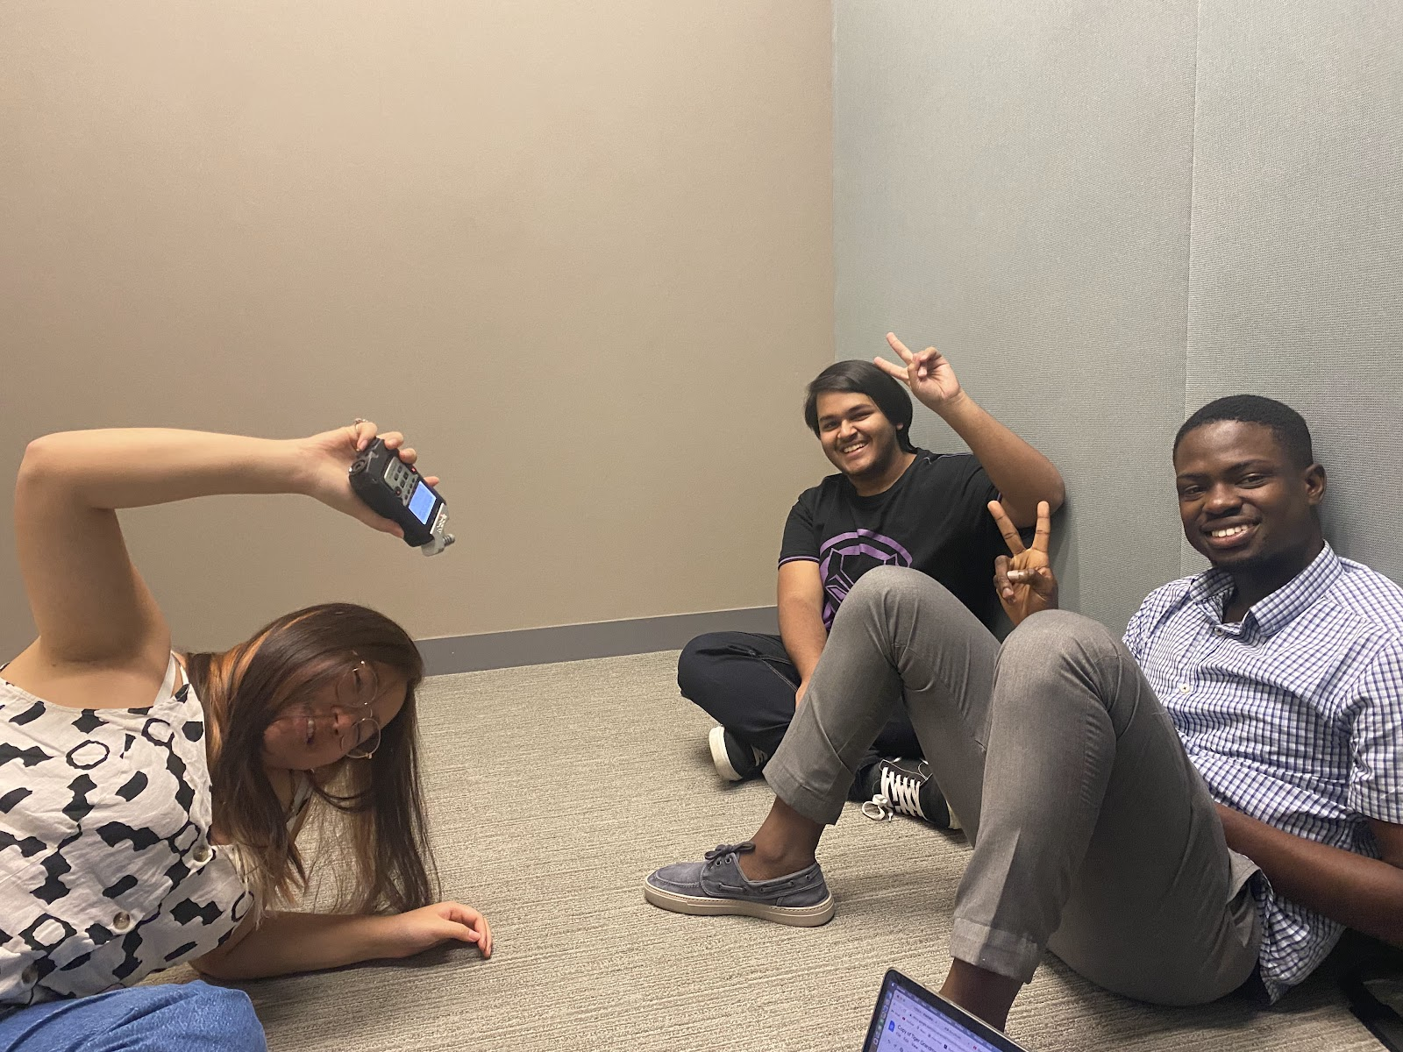

Figure 3 Behind the scenes of sound recording

# The sound was recorded using a Zoom H4 Recorder. Each line of the dialogue as presented in the script was recorded separately. The quality of voice acting was an obvious obstacle since none of the team members had ever participated in such activities, but the recording ran smoothly and was finished relatively quickly with respect to the team’s abilities. The sound was exported on a computer and its editing divided among two team members with one member editing scene 1 and the other scenes 2 and 3. Other sounds, which will be discussed later, were obtained from the internet.

## **Generating Visual Representation**

Generating a visually appealing representation proved to be a challenging task. The project involved a family from Taiwan, consisting of a mother, father, and daughter, and thus, it was essential to create images that accurately represented the characters and the scenes. However, the initial tool used, DALLE[1], failed to produce human faces with satisfactory results despite multiple iterations and prompts. Furthermore, it often generates bitter melon as watermelon. After several hours of experimenting with different prompts, the team switched to using one-line drawings. Nevertheless, one of the team members came across Dream.ai [2], which proved to be an effective image generation tool after several iterations of prompts. Ultimately, the team selected three visualisations, which were further enhanced by cropping tools and filters. The second scene featuring a lion and a little girl was given a dark filter to enhance its scary tone.

|  |
| --- |
| Figure 4 Family together at the dinner table |
| Figure 5 Tiger Grandma appears in the bedroom at night |
| Figure 6 Daughter wakes up from dream in the morning |

## **Website Design**

Before the website was implemented, a rough sketch of the wireframe was first laid out which encompassed the cover page (Figure 7), Sound playing pages (Figure 8), Ending page (Figure 9) and behind-the-scenes page (Figure 10).

|  |
| --- |
| Figure 7 Opening page wireframe |
| Diagram, text  Description automatically generated  Figure 8 Sound playing page wireframe |
| Text  Description automatically generated  Figure 9 Ending page wireframe |
| Diagram, shape, polygon  Description automatically generated  Figure 10 Behind the scenes page wireframe  To formally set out on completing the website, a title page (Figure 11) was created using Adobe Illustrator and Canva. The title shows both the Chinese and English versions of the project title.    Figure 11 Website title page  In order to monitor the flow of the website, intuitive buttons were created and their intended use designated.   |  |  |  | | --- | --- | --- | | Figure 12 Play button | Figure 13 Next Scene Button | Figure 14 Replay button | |

# **PHASE THREE: IMPLEMENTATION**

## **Sound Editing**

The sound editing was done using Audacity. Audacity is a free and open-source software that is widely used in the music industry for recording and editing audio. The two members chosen to edit the sounds had already prior experience with the software and, hence, faced little difficulty with finishing the project. The sounds for the first scene [3-14] were retrieved from Pixabay, a site providing royalty free sound effects. All of the sounds were edited in Audacity. They were either shortened, pitched differently or repeated such as to accommodate the needs of the project.

The first scene needed to emulate a family dinner. Combining the myriad of sound with the team’s recorded dialogue was very successful in illustrating the atmosphere, even without the visual aid. The team focused mainly on sound within this project. For example, the sound of thunder [12] was used to show anger of the mother within the first scene and the slamming of the door [14], the anger of the daughter after the fight with her parents. The first scene was the longest scene in the audio and was thus very important to set the ground for the two following scenes without telling the story in its entirety.

The second scene is situated in the daughter’s bedroom. She had fallen asleep and was woken up by the cold in the middle of the night. We wanted to create sounds that would produce a sense of space, so we added the sound of wind blowing through the window [18] to justify the daughter waking up in the cold. The daughter then walked from her bed to the window to close it. We added footsteps sound and window closing sounds [17, 19]. In this scene, we also have to introduce the existence of the spooky tiger grandma, so in the background we have a mysterious ambience music [16] and we have a monster growl sound effect [21] before the daughter screams to signify that she saw the tiger grandma. To make the tiger grandma’s voice scary, we also adjusted the pitch and implemented an echoing effect. After the daughter and the tiger grandma had the conversation, a loud monster roar sound is added to hint to the audience that the daughter is eaten [15].

The last scene brings the story to conclusion. The daughter wakes up to birds chirping [20] and can’t stop heaving loudly from the scary dream. Using the sounds, we created a beginning (Scene 1), a middle (Scene 2), and an end (Scene 3) to tell the story of an old Taiwanese folklore.

## **Website Development**

To start out, random stock pictures and sounds were used to create the flow of the website. This helped to understand how the website would pan out from one scene to the next. Later these pictures were replaced with the graphics the team created and the sounds were replaced with the sounds generated from audacity.

The first step in the implementation of the website was to create the flow of the different scenes. To start out, random stock pictures and sounds were used to create the flow of the website. This helped to understand how the website would pan out from one scene to the next. Later these pictures were replaced with the graphics the team created and the sounds were replaced with the sounds generated from audacity.

The flow was thought out to be in the following way:

* The cover page would consist of a play button. As soon as the button is clicked, the cover photo would be removed and the scene 1 photo would be set. Almost instantaneously, the audio file for scene 1 would be played.
* The user would stay on scene 1 until the audio stops playing. This is when they would find an arrow appear at the bottom of the screen. It would allow the user to navigate to the next scene.
* The step above would be repeated for scene 2 and scene 3.
* Finally at the end of scene 3 when the audio stops playing, a replay button and a navbar would appear. There would be no arrow as there aren’t any more scenes that are left. The navbar would have options of “Behind the Scenes” and “The Original Tiger Grandma story”.
* Clicking the replay button would take the user back to the first screen with the cover photo and the play button. The reason the replay button doesn’t immediately start from scene 1 is so that the user gets the control on when to exactly restart and is able to see the cover page again.

The flow was implemented by using a combination of event listeners (for click and audio endings), counters (to determine the next scene image and audio), display property of the images, and pause and play property of the audio (the code is available in the appendix section with comments).

The interactive component of the website was to provide the experience of the audio through controllable scenes. The user has the options to play, replay, and move through the scenes. This interconnected network allows the user to immerse in an interactive experience moving through the graphics of different scenes that accentuates the final audio used in each of the scenes.

|  |
| --- |
| Figure 15 Opening page |

|  |
| --- |
| Figure 16 Scene 1 (after audio ends) |
| Figure 17 Scene 2 (before audio ends) |
| Figure 18 Replay page |

The "Behind the Scenes" page was designed to showcase the intricate work that went into the project. The gallery features interactive images that are set against a bold black background, allowing them to truly stand out and captivate the viewer.

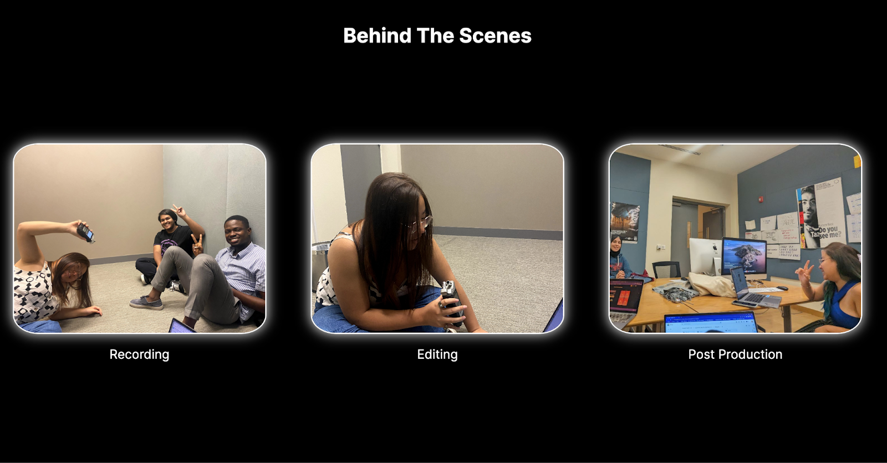

Figure 19 Behind the scenes page

# **PHASE FOUR: DELIVERY**

The last phase was the delivery phase. This phase encompasses the publishing of the website, its moderate testing, and the writing of the documentation. The team published the website on GitHub Pages and all of the members tested the functionality of the website by visiting the repository. The delivery phase also meant presenting the website which was done during the Communications Lab class.

# **REFLECTION**

By highlighting the importance of cultural preservation and the role of sound in storytelling, the team found it important to understand how a project focused on sound production can help people appreciate cultural heritage and gain a deeper understanding of storytelling. The fact that team members from different backgrounds were involved in the project shows the universality of storytelling and the power of sound to transcend cultural boundaries. Each of us was also able to perform in sounds in the recording session of the project. In participating in the storyline by acting, we were able to immerse ourselves in the cultural experience. Focusing on the elements of sounds that helped create a sense of space, for example the wind, thunder, and footsteps, and dialogues that move the storyline forward, the project helped the team understand the intricacies of sound production and the art of storytelling. Overall, this project provided a practical opportunity in sound editing and production training and an insightful reflection on the intersection of culture, sound, and storytelling.

Table 1 Three Week Overview Plan

|  |  |  |  |
| --- | --- | --- | --- |
| **Plan** | Week 1 | Week 2 | Week 3 |
| - Practice storytelling fundamentals |  |  |  |
| - Brainstorming Idea |  |  |  |
| - Brainstorm dialogue |  |  |  |
| - Create storyboard/script |  |  |  |
| - Allocate design/implementation roles |  |  |  |
| **Design** |  |  |  |
| - Design characters & setting |  |  |  |
| - Design main title page |  |  |  |
| - Ideate visual aids |  |  |  |
| - Find needed audio and images |  |  |  |
| - Design website |  |  |  |
| **Implementation** |  |  |  |
| - Create and edit AI art |  |  |  |
| - Add the sound audio to website |  |  |  |
| - Add buttons after sound has played |  |  |  |
| - Add BTS and story links to website |  |  |  |
| - Add images to website |  |  |  |
| - Meet together to finalise all aspects in conjunction |  |  |  |
| - Run GitHub website |  |  |  |
| **Delivery** |  |  |  |
| - Publish the website |  |  |  |
| - Write documentation |  |  |  |
| - Submit project on Brightspace |  |  |  |
| - Present in class |  |  |  |

# **REFERENCES**

[1] OpenAI. (n.d.). DALL-E. https://openai.com/dall-e/

[2] Dream AI. (n.d.). Dream AI. <https://dream.ai/>

[3] *181120-walking-running-up-and-down-stairs-old-house-london-on-57589 | royalty free music - pixabay*. (n.d.). Retrieved April 11, 2023, from <https://pixabay.com/sound-effects/181120-walking-running-up-and-down-stairs-old-house-london-on-57589/>

[4] footsteps-on-wood-floor-14735 *| royalty free music - pixabay*. (n.d.). Retrieved April 11, 2023, from <https://pixabay.com/sound-effects/footsteps-on-wood-floor-14735/>

[5]  fork-on-plate-6764 *| royalty free music - pixabay*. (n.d.). Retrieved April 11, 2023, from <https://pixabay.com/sound-effects/fork-on-plate-6764/>

[6] hit-on-table-43639 *| royalty free music - pixabay*. (n.d.). Retrieved April 11, 2023, from <https://pixabay.com/sound-effects/hit-on-table-43639/>

[7] pushing-pulling-chair-table-wooden-furntiure-across-hard-floor-pack-26311 *| royalty free music - pixabay*. (n.d.). Retrieved April 11, 2023, from <https://pixabay.com/sound-effects/pushing-pulling-chair-table-wooden-furntiure-across-hard-floor-pack-26311/>

[8] rain-and-thunder-nature-sounds-7803 *| royalty free music - pixabay*. (n.d.). Retrieved April 11, 2023, from <https://pixabay.com/sound-effects/rain-and-thunder-nature-sounds-7803/>

[9] sigh-100805 *| royalty free music - pixabay*. (n.d.). Retrieved April 11, 2023, from <https://pixabay.com/sound-effects/sigh-100805/>

[10] table-slam-102489 *| royalty free music - pixabay*. (n.d.). Retrieved April 11, 2023, from <https://pixabay.com/sound-effects/table-slam-102489/>

[11] Ten Yu-Hsien-The Torment of a Flower | *youtube*. Published Jan 28, 2012. Retrieved April 11, 2023, from <https://www.youtube.com/watch?v=qflbyptHSlQ>

[12] thunder-124463 *| royalty free music - pixabay*. (n.d.). Retrieved April 11, 2023, from <https://pixabay.com/sound-effects/thunder-124463/>

[13] wooden-chair-push-in-pull-outwav-14414 *| royalty free music - pixabay*. (n.d.). Retrieved April 11, 2023, from <https://pixabay.com/sound-effects/wooden-chair-push-in-pull-outwav-14414/>

[14] wooden-door-slamming-close-79934 *| royalty free music - pixabay*. (n.d.). Retrieved April 11, 2023, from <https://pixabay.com/sound-effects/wooden-door-slamming-close-79934/>

[15] Tiger Roar Sound Effect | *youtube*. Published Aug 11, 2017. Retrieved April 12, 2023, from <https://www.youtube.com/watch?v=nwq249Me9Yk>

[16] mysterious-celesta-114064 | *royalty free music - pixabay.* (n.d.). Retrieved April 12, 2023, from <https://pixabay.com/music/mystery-mysterious-celesta-114064/>

[17] Footstep sound effects | *youtube*. Published Mar 12, 2019. Retrieved April 12, 2023, from <https://www.youtube.com/watch?v=9g7uukgq0Fc>

[18] Wind Blowing Sound Effect | *youtube.* Published Nov 7, 2020. Retrieved April 12, 2023, from <https://www.youtube.com/watch?v=vtaeGK0KAxs>

[19] Window Closing Sound Effect | *youtube.* Published Nov 2, 2021. Retrieved April 12, 2023, from <https://www.youtube.com/watch?v=Dw2sTWk7LAE>

[20] cardinal - 37075 | *royalty free music - pixabay.* (n.d.).etrieved April 12, 2023, from <https://pixabay.com/sound-effects/cardinal-37075/>

[21] monster-roar-6985| ​​| *royalty free music - pixabay.* (n.d.).etrieved April 12, 2023, <https://pixabay.com/sound-effects/monster-roar-6985/>

# **APPENDIX**

***index.html***

|  |
| --- |
| <body>     <!-- navbar -->     <nav class="navbar">         <div class="navbar-logo"><img src="./assets/logo_nobg.png" alt=""></div>         <ul class="navbar-menu">             <!-- links to the behind the scenes page -->             <li><a href="./bscene.html" target="_blank">Behind the Scenes</a></li>             <!-- links to the real story of tiger grandma -->             <li><a href="https://islandfolklore.com/tiger-aunt/" target="_blank">The Original Story</a></li>         </ul>         <!-- makes the navbar responsive -->         <div class="navbar-toggle">&#9776;</div>     </nav>     <!--all the buttons and scenes  -->     <img src="./assets/play_button.png" alt="" id="play">     <img src="./assets/cover.png" alt="" id="cover">     <img src="./assets/sample1.jpg" alt="" id="s1">     <img src="./assets/sample2.jpg" alt="" id="s2">     <img src="./assets/sample3.jpg" alt="" id="s3">     <img src="./assets/next_scene_arrow.png" alt="" id="arrow">     <img src="./assets/replay_icon.png" alt="" id="replay">     <script src="app.js"></script>  </body> |

***app.js***

|  |
| --- |
| // defining variables for DOM elements  const arrow = document.querySelector("#arrow");  const navbar = document.querySelector(".navbar");  // importing audio files  const track1 = new Audio('./assets/sounds/track1.mp3');  const track2 = new Audio('./assets/sounds/track2.mp3');  const track3 = new Audio('./assets/sounds/track3.mp3');  // waiting for window to load all sound files and images completely before proceeding  window.addEventListener("load", () => {     // event listeners     // checking when a audio file ends playing, making the arrow display, and getting ready for audio change     track1.addEventListener('ended', function () {         console.log('Audio1 finished playing');         track_fin = 1;         arrow.style.display = "block";     });     track2.addEventListener('ended', function () {         console.log('Audio2 finished playing');         track_fin = 2;         arrow.style.display = "block";     });     track3.addEventListener('ended', function () {         console.log('Audio3 finished playing');         track_fin = 3;         replay.style.display = "block";         navbar.style.display = "flex";     });     let track_fin = 0;     // click event listener for the play button     play.addEventListener("click", () => {         play.style.display = "none";         cover.style.display = "none";         s1.style.display = "block";         track1.play();     });     // click event listener for the arrow button     let count = 0; //count helps in deciding which scene has to be displayed next     arrow.addEventListener("click", () => {         if (count == 0 && track_fin == 1) {             s1.style.display = "none";             s3.style.display = "none";             s2.style.display = "block";             count++;             track1.pause();             track2.play();             arrow.style.display = "none";         } else if (count == 1 && track_fin == 2) {             s2.style.display = "none";             s1.style.display = "none";             s3.style.display = "block";             arrow.style.display = "none";             track2.pause();             track3.play();         }     });     // click event listener for replay button     replay.addEventListener("click", () => {         s3.style.display = "none";         s1.style.display = "none";         replay.style.display = "none";         cover.style.display = "block";         navbar.style.display = "none";         play.style.display = "block";         count = 0;         track_fin = 0;         track3.pause();     });  }); |

***bscene.html***

|  |
| --- |
| <body>     <h1>Behind The Scenes</h1>     <!--Container for the images-->     <div class="container">         <div class="image-container">             <img class="image" src="./assets/bscene1.png" alt="Image 1">             <p class="image-text">Recording</p>         </div>         <div class="image-container">             <img class="image" src="./assets/bscene2.png" alt="Image 2">             <p class="image-text">Editing</p>         </div>         <div class="image-container">             <img class="image" src="./assets/bscene3.png" alt="Image 3">             <p class="image-text">Post Production</p>         </div>     </div> |

***bscene.css***

|  |
| --- |
| @import url('https://fonts.googleapis.com/css2?family=Inter:wght@100;200;400;700&family=Questrial&display=swap');  body {     background-color: black;     font-family: "Inter";  }  h1 {     color: white;     text-align: center;     margin-top: 50px;  }  .container {     display: flex;     justify-content: space-around;     align-items: center;     height: 80vh;  }  .image-container {     display: flex;     flex-direction: column;     align-items: center;  }  .image {     width: 400px;     height: 300px;     border-radius: 10%;     object-fit: cover;     box-shadow: 0 0 20px white;     border: 2px solid white;     transition: all 0.5s ease-in-out;  }  .image:hover {     transform: scale(1.1);     border: 2px solid#24B3A8;     box-shadow: 0 0 20px #24B3A8;  }  .image-text {     color: white;     margin-top: 20px;     font-size: 20px;     text-align: center;  }  @media only screen and (max-width: 768px) {     .container {         flex-direction: column;         align-items: center;         height: auto;     }     .image {         margin: 20px 0;     }  } |